
US Sailing Book Offer 

Ahoy all PSC Cruising Skippers and Candidates. Below you will find a special offer on US Sailing Cruising Text Books.

This special offer is made available to the PSC through our affiliation with the US Naval Sailing Association (USNSA)

The first three books are highly recommended for any members who will ultimately take the Cruising Skipper Exams. The fourth book is a great reference book for those skippers who might be doing a little longer distance sailing.

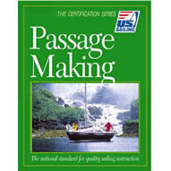
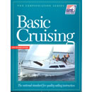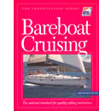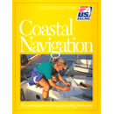

$12 $12 $15 $22

If you wish to purchase any of these books, please contact either the Training Commodore trainingcommodore@pentagonsailing.org or the Bay Training Coordinator baytraining@pentagonsailing.org for specific payment information.

Also, please note that if you are new to the club and are considering entering the Cruising Skipper Training Program, you can save $4.00 off the cost of entering the program buy taking advantage of the package deal. The package deal is the PSC Cruising Skipper Checksheet and Logbook along with Basic Cruising, Bareboat Cruising and Coastal Navigation for only $45. Please see http://www.pentagonsailing.org/btp.htm - declare for more information.

